TRAVEL TIPS FOR GREECE
In Greece, you are standing at a crossroads of cultures, colours and civilizations, you feel the strength of history and the warmth of being in the southernmost part of Europe, you discover an evolutionary process of thought, influence and experience. A country that despite being rich in history has a population that moves towards the future. A country that although statistically small, is huge in its diversity.
A landscape that has given us thousands of postcard images but remains incredibly vibrant and impossible to capture. Greece is a country of beautiful contradictions, a constant journey in time, from the present to the past and back again. Walk through the olive groves, through ancient sites. Move to clusters of sparsely inhabited islands. Roam from the beaches to Rocky Mountains and explore breathtaking scenery.
In Greece the fusion of images becomes more than imagery and turns into reality.

Explore your senses in Greece !!

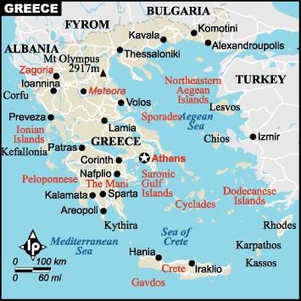

VISAS: The visa is to be obtained prior to arrival in the country
NOTE :- Further, any change in fees, additional documents or personal presence of the applicant might be required which is on the discretion of the embassy.

GEOGRAPHY:
The country of Greece is located in southeastern Europe, on the southern end of the Balkanic peninsula. Greece is surrounded on the north by Bulgaria, the former Yugoslav Republic of Macedonia and Albania; to the west by the Ionian Sea; to the south by the Mediterranean Sea and to the east by the Aegean Sea.

The country consists of a large mainland; the Peloponnese, a peninsula connected to the mainland by the Isthmus of Corinth; and around 3000 islands, including Crete, Rhodes, Corfu, the Dodecanese and the Cyclades. Greece has 15000 kilometres (9300 miles) of coastline. 80% of Greece is mountainous, and the country is one of the most mountainous countries of Europe

Why to choose Greece?

There are many new tourist destinations added to the international market and there are others that enforce their place with the advantage of the low cost.
In such a competitive environment, Greece can be low cost providing strong advantages the historic and cultural riches:
- Its unique phenomenon of numerous islands.
- Its natural resources.
- Safety, which is so important in our days
- Its gastronomy and the healthy Greek Mediterranean cuisine, which has been globally accepted as a long living factor.
- The traditional warm hospitality.
- Continuous upgrading accommodation product.
- Birth place of the Olympic Games.
- Birth place of the Medicine - Hippocrates oath.
- Birth place of sciences
- Cradle of culture, civilization a world within a small country like Greece.

TIME:
Greece is Three hours and thirty mins behind us.

CLIMATE:
Spring and autumn are the best times to visit Greece. Conditions are perfect between Easter and mid-June - the weather is pleasantly warm in most places, but not too hot; beaches and ancient sites are relatively uncrowded; public transport operates on close to full schedules; and accommodation is cheaper and easier to find than in the mid-June to end of August high season. Conditions are once more ideal from the end of August until mid-October as the season winds down. Winter is pretty much a dead loss outside the major cities as most of the tourist infrastructure goes into hibernation from the middle of October till the beginning of April. This is slowly changing, however; on the most touristy islands, a few restaurants, hotels and bars remain open year-round.
CURRENCY: Euro

ELECTRICITY:
The electrical current is 230 volts, AC 50Hz. you will need an adaptor socket for the same.

Health Concerns
Medical facilities are adequate but there can be long waits at hospitals to receive treatment. A reciprocal agreement with all European Union member states means that emergency medical and dental treatment is free for all EU citizens and those from Norway, Iceland, Liechtenstein and Switzerland on presentation of a valid EHIC (European Health Insurance Card, which replaces form E111 as of January 1, 2006). If you do not already have a EHIC, applications can be made through the post office or department of health in your country. Greece also offers reciprocal healthcare agreements with other European countries. You should check before travelling as to whether any such agreement exists between your country of origin and Greece. The system is poorly implemented and it is advisable to take out appropriate travel insurance, especially if you plan to indulge in watersports or any other activity that carries a level of risk.
Tap water in rural areas and small islands is not considered safe to drink and you are advised to drink bottled water.
Emergency Numbers
Police- Tel: 100
Ambulance Tel: 166
Fire Tel: 199

Shopping
The best buys in Greece include locally made lace, and silver jewellery such as neck chains, rings and earrings (especially those from Ioannina). Other good buys include Greek music CDs and traditional Flokati rugs.
Ceramics from most of the islands, and especially Sifnos and Skopelos, is a great buy. You'll also find fabulously priced leather and fur goods almost everywhere. Belts, handbags, hats and other items are best bought in markets where you can haggle for the best deal, but you'll never pay over the odds in any case. Quality is generally good for all such items.
In Athens, 22-karat gold jewellery can be a very good buy as expert craftsmanship is cheaper here than just about anywhere else in Europe.
If you like embroidered tablecloths and clothes then do your shopping in Rhodes, Crete or Skiros.
As Greece is so well known for its statues and monuments, great mementoes are masks, busts and reproductions of famous Greek art. Souvenir reproductions should cost no more than EUR30. Remember though that the unauthorised purchase of genuine antiquities is strictly forbidden.
Wine and alcohol of all kinds are inexpensive and a bottle of ouzo makes a perfect gift to take back home
Opening Hours
Shops tend to close for a couple of hours during the afternoon and are open from 09h00-15h00 and again from 17h30-20h30, Mon-Fri. Most shops open earlier in the summer and close later.
CIMATE: Conditions are perfect between Easter and mid-June - beaches and ancient sites are relatively uncrowded; public transport operates on close to full schedules; and accommodation is cheaper and easier to find than in the mid-June to end of August high season. Conditions are once more ideal from the end of August until mid-October, as the season winds down. Winter is pretty much a dead loss outside the major cities as most of the tourist infrastructure goes into hibernation from the middle of October till the beginning of April. This is slowly changing, however; on the most touristy islands, a few restaurants, hotels and bars remain open year-round, while the ski resorts on the mainland do thriving business.

To get there:

By Train
Greece has a limited though competent train network. There are no trains on the islands.
Train journeys tend to be cheap when compared with other forms of transport; for example, it would cost about EUR16 to travel from Athens to Thessaloniki, second class.
Train travel offers the possibility of some classic journeys: The Trikala-Karditsa-Kalambaka (Meteora) journey ends with the imposing site of the Meteora monasteries, while the Tripolis-Kalamata route involves 30 separate 180 degree turns from the train as it winds its way up the mountain pass.
You are advised to purchase your tickets in advance as buying on the train incurs a 50 per cent surcharge. Generally return fares are 20 per cent cheaper than two single tickets and a 30 per cent discount is obtainable for groups of 6 or more.
Both Eurail and InterRail tickets are valid in Greece.
The Greek Flexipass ticket gets you 3 days first-class travel in any one month for USD86, and then various combinations up to 5 days for USD120.
Within Greece, dial 145 for information on domestic railway schedules; dial 147 for international schedules.
By Bus
Buses are the best way to explore the country - there are routes to all major cities and local services link most towns and villages.
Look out for two types: long distance buses are light beige and green, while city buses are blue. Both services are very cheap. A journey of 30 kilometres will cost about EUR4. Buy your ticket on the bus or at kiosks in towns and cities.
Leave plenty of time for journeys on smaller islands, as services can be infrequent.
In recognition of the sometimes erratic nature of the public transport network some hotels have mini-bus services and occasionally even boats to take guests around islands or the immediate locale.
By Car
The following table provides approximate driving distances between Greek cities. Kilometres in the lower left of the table, miles in the upper right.
City | Ath | Del | Met | Oly | Cor | Ath | The
Athens | • | 110 | 217 | 163 | 51 | 390 | 309
Delphi | 177 | • | 135 | 128 | 96 | 308 | 227
Meteora | 349 | 217 | • | 250 | 232 | 227 | 146
Olympia | 263 | 207 | 403 | • | 115 | 424 | 343
Corinth | 81 | 154 | 373 | 1886 | • | 405 | 324
Athos | 628 | 496 | 366 | 682 | 652 | • | 81
Thessaloniki | 497 | 366 | 236 | 552 | 522 | 130 | •
By Air
Greece has 16 international airports and there are flights from Athens to every major city in Europe - as well as direct flights to and from the USA, Canada, various Asian cities and Australia. In the islands international airports can be found on Crete, Rhodes and Kos and several other popular islands.
Olympic Airways - the national carrier - operates flights between many of the islands and cities, but flying can cost about three times the price of a ferry ride. Tickets with Olympic Airways are sold at all major travel agencies in Greece.
By Boat
By far the best way to explore the islands is by ferry - and island hopping is a holiday in itself. An excellent network starts at Piraeus, a port near Athens. You can reach all the major islands in the Aegean from here, and then catch local ferries to smaller islands. Major routes use modern catamarans and hydrofoils. The trip from Piraeus to the Dodecanese, one of the longer journeys, would take five hours and cost about Approx EUR19. A short hop between two islands in one group should cost around Approx EUR8.
Dedicated sightseeing boat trips around the islands are widely available with local companies and are an excellent way of seeing the sights. Tickets are available from offices at the ports.
MAINLAND AND IMPORTANT SIGHTSEEING IN GREECE:
Mainland Greece can be broken down into small groups, which comprise Athens, the Peloponnese, Thessaly and Central Greece, Epirus and the West, and The North: Macedonia- Thrace.
Athens of course is the capital of Greece, and home to some of the most famous and popular sights in Greece, such as the Parthenon on the Acropolis that we referred earlier, The temple of Sounion, the Plaka also called "district of the gods", the "district of romantics", at the foot of the sacred rock of the Acropolis. An attraction for tourists seeking the local color of old Athens. and many others.
The Peloponnese, location in the south of Greece, is a very beautiful and popular destination for many holiday makers. The Peloponnese is steeped deep in history and folklore, and is home to many of Greece's best archaeological sites, such as Olympia, Mycenae, Corinth and Epidaurus.Thessaly and Central Greece is a region of Greece that is well known for it's natural beauty. Combining mountainous areas and beautiful beaches, as well as the large island of Evia, Central Greece is a perfect destination for holidays in Greece full of relaxation and peace.
The famous region of Delphi can be found to the south of the region of Central Greece, and is one of the most popular tourist attractions in Greece after the Parthenon in Athens.
With the stunning areas of Meteora and the famous monasteries, you will surely find this area full of simplicity, interest and beauty.

The Greek islands:

Three simple words, yet they are able to invoke so many visual pictures and memories, such as blue skies, sandy beaches, great entertainment, historical sites and so much more. Everyone who has ever visited one of the many Greek Islands will testify to their immense natural beauty, and the fact that there is nowhere else in the world quite like them.
The Saronic Gulf Greek Islands Aegina-Poros-Hydra are very popular to visitors of Athens, as they are very close to the mainland, and with easy access from the port of Piraeus, there can be no excuse for not visiting, at least, a selection of the islands to be found here.
Hydra
The Cyclades Greek Islands are probably the most famous and popular of all of the island groups in Greece. Consisting of 39 islands, of which 24 are inhabited, the Cyclades Islands are where you will find those glorious images of small white churches, set against a backdrop of blue skies and deep blue seas. The famous Greek islands of Mykonos, Santorini, Naxos and Paros all reside within this group. As well as having many interesting sites and places of interest, these islands also have a very popular nightlife and entertainment scene, with many bars, restaurants, discos, and other activities.
The stunning island of Crete, the largest of all the Greek Islands, is the last stop in the Mediterranean, before reaching Africa. It is almost a small country amongst itself. With many popular destinations all over Crete, it is one island that offers very different holidays, depending on where you plan to visit.
Whichever Greek Island you plan to visit on your holidays in Greece, you can be sure that you will have a wonderful time, filled with a combination of fun, adventure, relaxation, and of course, the famous Greek hospitality, which is known all over the world. With so many Greek Islands to choose from, each offering their own unique blend of history, entertainment, and natural beauty, you will be truly spoilt for choice.

ATHENS
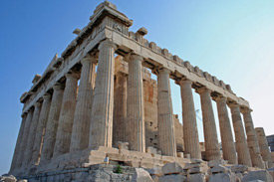
Athens, a city rich in History and tradition got ready to welcome the world. The birthplace of Socrates and Plato, home of philosophy and cradle of Democracy had the honour and responsibility, for the second time in modern History, to host the Olympic Games. Next to its timeless monuments like the Parthenon, the Agora and the Panathinaiko Stadium,
Athens has built a modern infrastructure of great architectural and technological value.
The city transformed its image to a modern, friendly place for Athenians and Visitors alike. Athens is a place that should be on your must see list. Although Athens has magnificent attractions, it is, also, a large, heavily populated, polluted, and relatively unfriendly metropolis. Athens has a lot to see and do: we recommend that you get to it and, then, head for the Islands or the countryside where the Greeks seem to be somewhat friendlier. To most tourists, Athens connotes an image of the Acropolis with the proud Parthenon beckoning us to come and sample three millennia of history. The National Archaeological
Museum of Athens is another shows topper.
Getting There
The new airport Eleftherios Venizelos at Spata was opened. It is hypermodern and with the new road connections through the Attiki odos and Metro, suburban rail. Without traffic jams it takes about 45 minutes to get there from the centre of Athens by the express buses (X 95 Airport Syntagma square ) (X 96 Airport Piraeus) , but unfortunately sometimes especially on weekdays pick hours, traffic jams are more rules than exceptions. But with the new extensions you can use the Suburban train (Proastiakos) until Neratziotisa station and continue with the Athens Metro that goes to Syntagma (blue line) or to Omonoia from Doukissis Plakentias station (green line).
If you are coming from the islands the ferry boats will stop at Piraeus, Port Rafina (Cyclades Andros) or Agios Konstantinos from the Sporades islands. Train (OSE) runs through the whole of Greece - starting in Thrace, through Thessalonica, Larisa to Athens, and is also connected with the Peloponnese.
Getting Around
In Athens while the overcrowded buses usually just pass the bus stops, leaving you there with a long face, the new Athens Metro is an excellent way to get around (it is also very beautiful, worth a visit just to see it). There are also electric trams and trolleys that are quite efficient to take you all the way to the Athens coasts. Taking a taxi can also be quite a horrific experience and there has also been reports of taxi drivers trying to overcharge foreigners. Make sure the taximeter is on and running properly and you won't have a problem.
In general, be careful when crossing the streets - green lights does NOT mean that you can cross the road without looking!!!

The first place you should visit when in Athens is of course the Acropolis. Standing up there, on the sacred rock as the Greeks call it, you can practically feel the magnificence of ancient Greece. Don't think you'll be alone there though.
Other archaeological sites are the agora, the market, with the temple to Hephaestus still in quite good shape, as well as the temple to Zeus and the arch of Hadrian.
Museums of interest are, amongst others, the Acropolis museum, the National Archeological museum, the Folklore museum, the Ceramics museum (Keramikos), the Byzantine museum, the Music museum, the War museum, the Benaki museum etc. All in all, there are about 50 museums in Athens. A popular place for shopping or food and drink is Plaka, just below the Acropolis. It is considered quite a touristy area, but the fact is that you here can get an idea of old Athens, with low buildings and little streets.
In Monastiraki there is a bazaar which is quite incredible, in Hephaestou street and around the small square of At the Syntagma Square you can visit the Tomb of the Unknown soldier. Here you can see the guards in their impressing uniforms, the Evzones, and if you are lucky you will see the slow and complicated change of guards. You can also feed pigeons here. Interestingly, there used to be a tomb to the unknown hero in ancient Athens. The opera, Megaron Mousikis, holds many wonderful performances, but even lovelier is the Herodes Atticus theatre just below the Acropolis.
What to Do
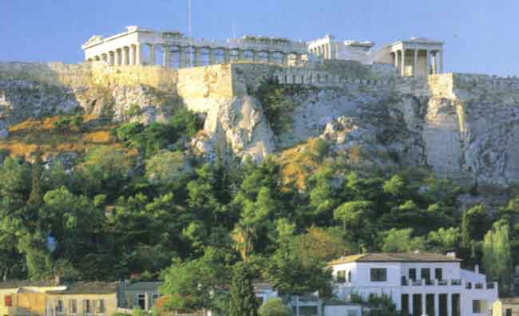
Athens Greece has such a wide variety of things to do that it almost is no idea to write it all down. For example, you have all the sights and the museums, concerthalls and theatres. Then, there are many cinemas, a great nightlife, bazaars, fashion shops and super modern shopping malls. Go up to the Lycavitos hill and get a wonderful view. You can go to Athens Riviera from Paleon Faliron up to Kalamaki ,Alimos ,Glyfada ,Vouliagmeni and Varkiza for some sun and sea. You can visit as well the National gardens that are located next to the Parliament at Syntagma square.
Beaches
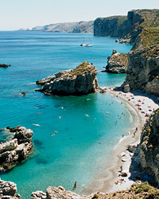
There are several beaches at Athens Riviera The most popular ones are in Glyfada, Vouliagmeni, Varkiza, Nea Makri, Crysi Akti (Golden Coast ), Lagonisi, Kavouri and Alimos. Most of the beaches in Athens are organize and you have to pay a small entrance fee to these beaches - this is to keep them clean since it has millions of visitors every summer.
Nightlife
Jazz bars, discos, bouzoukia clubs, heavy metal bars - it's all here. There are places all over Athens, but the most frequented areas are Syntagma, Kolonaki and Glyfada. Almost in every square in all Athenian suburbs there are Cafeterias and bars that during the night are becoming music bars with professional DJ's.
Food and restaurants Just like the bars, the restaurants and taverns are everywhere in Athens. The Plaka area is probably the most picturesque, but also the most visited by tourists. Keep a lookout for the places with lots of Greeks in them - that applies all over Greece. In Syntagma and Kolonaki there are also many places, and in Glyfada and Vouliagmeni you are close to the sea, and the atmosphere is usually a little bit more sophisticated. The area Psiri not far from Acropolis is very expensive with lots of lovely places with live music day and night. In Athens you will find a plethora of fast food like Mc Donald's ,Wendy's the Greek chain of Goody's ,Pizza hut ,Starbucks, and many other famous chains but the most typical fast food in Greece is the souvlaki .
Shopping
Being Greece's capital you can find everything if you for shopping in Athens. The big shopping street is Ermou, just off Syntagma square, Glyfada and Kolonaki are the exclusive quarters with many boutiques and shops. In Plaka you'll find lots of souvenirs from all over Greece, and the biggest department store is Vassilopoulos. In Monastiraki there is a great flea market every day and many antiquity shops. These are just a few example though, there are shops just about everywhere. At Athinas street you will find many interesting shops that sale herbs and many shops that sale dry fruits and nuts also at the same street located the main fish and meat market of Athens both are worth visiting.
PELOPONNESE
The Peloponnese is considered to be one of the most representational regions of the country as far as natural beauty, archaeological findings and the Greek historical background are concerned. The particularly picturesque Peloponnese, pulsing with numerous spots of multifarious interest, is regarded as one of the most appealing districts of Greece, attracting innumerable visitors all year round. The district of the Peloponnese, situated on the southwestern part of continental Greece, comprises of seven non - identical prefectures, which are all ideal destinations for your summer or winter vacations. Argolida, Arcadia, Achaia, Elia, Corinth, Laconia and Messinia, throbbing with cosmic towns, scenic villages, archaeological sites and natural spots, shall definitely be the supreme escapade from your everyday routine.
Other Attractions: Cornitha, Tripoli, Sparti, Kalamata, Olympia, Nafplio, Hydra

How to get there Flights to Athens or Kalamata will usually be the most convenient - depending on where your trip to the Peloponnese starts from. If you are visiting the West (for example Gerolimenas, Itilo and so on) it will reduce driving and local travel times if you can fly to Kalamata.

There are many international, domestic and charter flights to Athens from all over Europe and international flights from the USA and other continents. To Kalamata (airport code: KLX) there are domestic flights from Athens and international charter flights (though few of them) from the UK and some European countries.

By air and sea:
AirSeaLines is the new romantic and scenic way. Air Sea Lines operate flights in 19-seat De Havilland Twin Otter seaplanes from summer 2005. Schedules will include connections: Patra-Corfu, Patra-Kefallonia and perhaps more later.By ferry:
From Athens (Pireas or Rafina) you can take Flying Dolphins (hydrofoils and catamarans) to Monemvasia, Poros, Hydra and Spetses (just off the Peloponesse east coast). Some are seasonal. From Italy ferries sail to Patra.
Ferries to surrounding islands:
Zakynthos, Kefallonia, Kithira and Crete (though this is a slow ferry and a bit old - hopefully it will be upgraded - sometime!), Aegina and some trips from Athens to Monemvasia, Poros, Spetses and Hydra.
By train:
From Athens to Nafplion, Pyrgos and Kyparissia; to Argos and Tripoli (the latter two terminate in Kalamata).
By car or bus:
- Driving from Athens or Pireas port, crossing the Corinth canal by road (New National Road - toll payable...or old winding road along the coast edge.
- Coming from central-west Greece: drive across the new and spectacular Rio-Antirio cable bridge (you arrive at Rio town, a few km east of Patra). Toll payable.
- By bus: most cities are connected to Athens and with each other by KTEL (long-distance) buses.Driving times in Peloponnese:
When planning trips driving times are deceptive if you look at a map and are not familiar with the areas you will explore. Once off the very few main roads - it is best to estimate an average rate of progress of 45 Kilometres per hour as many roads are narrow, vary in surface quality and are twisting, winding routes.Watch out for tractors and quite a few lorries/trucks (they have to get that wine and other produce delivered one way or another!).
You might find useful our driving in Crete feature - mosts tips are valid for the Peloponnese too.

CENTRAL GREECE:
Central Greece is a landscape both physically and historically dramatic and has been the setting for many heroic struggles, both mythical and moral. With its rugged mountains and fertile valleys it promises the adventurous travelers rich rewards. Meteora is an area in Thessaly (Central Greece) and Kalampaka is the city underthe rock towers of Meteora. The thing that makes Meteora so special is the monasteries on the top of the rock towers. The monasteries, the amound of peaks to climb and the paths for hiking brings in Meteora the whole year by many tourists.

MACEDONIA
Macedonia is the second largest prefecture in Greece and its capital, Thessaloniki is the second largest city in Greece. Thessaloniki, which is one of the few Greek cities to have experienced constant cultural development, has continuously played a significant role in both Greek and world history. The beautiful Prespa lakes are one of Europes most important bird sanctuaries and Mount Olympus is the highest mountain in Greece.The city of Kastoria on lake Orestiada is considered to be Greece’s most beautiful city by the Greeks themselves. The Halkidiki Peninsula with its three prongs of Kassandra, Sithonia and Mount Athos run from crowded tourist resorts to beautiful remote beaches all the way to simple monasticism
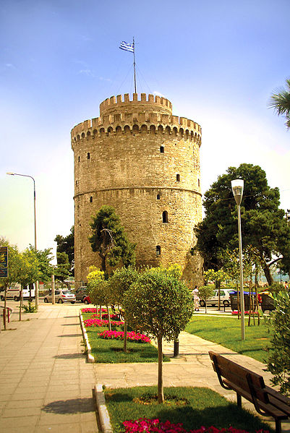
The White Tower of Thessaloniki was used as a prison during the era of the Ottoman Empire. Today it is a museum and the landmark of the city.
The climate of Macedonia can be categorised into two types that influence well-defined regions of its territory. The two distinct types are the Alpine and the Temperate/Mediterranean types. The Alpine type is dominant mainly in the mountainous areas of Western Macedonia and the Temperate/Mediterranean type affects Central Macedonia and East Macedonia and Thrace; it features cold, damp winters and hot, dry summers. The lowest temperature officially measured in Greece was recorded at Ptolemaida, in Western Macedonia, and was −27.8 °C (−18.0 °F).
HOPING OF ISLANDS
The islands are Greece’s chief morphological trait and an integral part of the country’s civilization and tradition. The Greek territory comprises 6,000 islands and islets scattered in the Aegean and Ionian Sea, a truly unique phenomenon on the European continent; of these islands only 227 are inhabited.

CRETE:

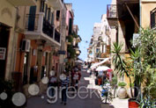
The largest of the Greek Islands, Crete has been a stepping-stone to Europe from the Middle East, Asia, and Africa. Crete features fantastic beaches and extensive, interesting archaeological digs related to the Minoan Civilization. Be sure to visit the Palace of Knossos, home of King Minos, originally constructed almost four thousand years ago. Crete island is the largest of Greece and is located in the south of the Aegean Sea. Crete is one of the most famous Greek islands. It is separated in 4 prefectures: Chania, Heraklion, Lassithi and Rethymno. The island has everything to offer: mountainous landscapes, a coast with many beautiful beaches and rocky coves, beautiful towns and charming villages and harbors, excellent food, ruins of the Minoan Civilization, one of the greatest civilization ever, an exciting nightlife…

Climate:
The climate of Crete Island is the mildest of Greece and maybe of Europe, gentle and healthy.

MONTH | Max. Temp°C | Max. Temp°F | Average daytime temperature |  | Water Temp°C | Water Temp°F | Days of rain
January | 16 | 61 | 12°C | 52°F | 16 | 61 | 14
February | 16 | 61 | 13°C | 54°F | 15 | 59 | 11
March | 17 | 62 | 14°C | 57°F | 16 | 61 | 8
April | 20 | 68 | 17°C | 62°F | 17 | 62 | 6
May | 24 | 75 | 24°C | 75°F | 19 | 66 | 3
June | 28 | 82 | 24°C | 75°F | 22 | 72 | 1
July | 29 | 84 | 26°C | 79°F | 24 | 75 | 0
August | 29 | 84 | 26°C | 79°F | 25 | 77 | 0
September | 27 | 81 | 24°C | 75°F | 24 | 75 | 2
October | 24 | 75 | 20°C | 68°F | 23 | 74 | 6
November | 21 | 70 | 17°C | 62°F | 20 | 68 | 8
December | 17 | 62 | 14°C | 57°F | 17 | 62 | 9

SANTORINI (THIRA):
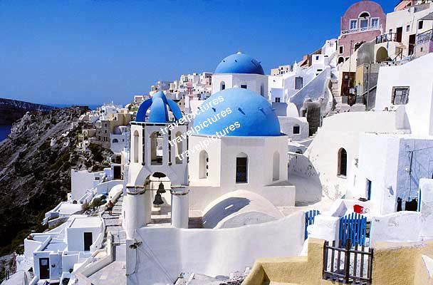

Santorini seems to tempt fate, as many of its villages sit on the sides of steep cliffs, in the midst of a caldera that resulted from the collapse of a volcanic cone: however, it is precisely this setting that causes Santorini to be such a spectacular destination. Be sure to visit the excellent archaeology site, Akrotiri, which features a Minoan settlement preserved by the eruption of the volcano. Finally, spend some time in the water and lounging on Santorini.s fine beaches. The Greek island of Santorini Greece or Thera is located in the Cyclades islands, in the Aegean Sea, Mediterranean at coordinates 36°25' N 25°26' E . Santorini Island Greece is with Mykonos, the most famous holiday destination. It is a small group of volcanic islands and its name was given by the Venetian in reference to Saint Irene. The island was also called Strongili and Kalisti and was the site of one of the largest volcanic eruptions but what remains today is a submerged volcano and a caldera.
The island of Santorini is related to the myth of Atlantis, the amazing views from the villages of Fira, Oia perched on cliffs, the sunset, the black and red beaches, the wine ...

Beaches:
Location: 15 km south-east of Fira.
Description: Perissa is a beach resort situated 15 km south-east of Fira. It is a very touristic village which offers an impressive long and comfortable black sandy beach.
Nearest village: Perissa

Kamari Location: 10 km south-east of Fira.
Description: The beach resort of Kamari is situated on the exact opposite side of Perissa, with the enormous rock (Mesa Vouno) in the middle.
Nearest village: Kamari

Red beach Santorini:
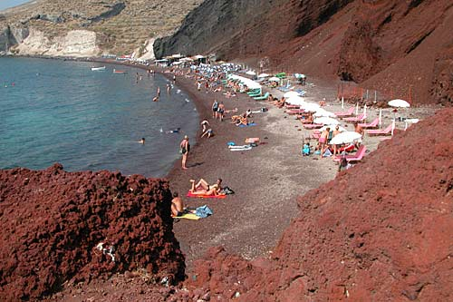
The red beach is one of the most famous and beautiful of the beaches of Santorini. It is located near the village and ancient site of Akrotiri. Because it is smallish, the red beach gets quite busy. A number of people come onto the headland just to admire this beach and never make it down to the hot sand. The reason why it attracts so many people is because of the slabs of red and black volcanic rocks behind it. Indeed one walks from the car park over a rocky route before it comes into view. If you look along the rock you can see it gradually turn white and the next beach obtains its name from this. The sand itself is reddish black and painful to sit straight onto. There are thus a lot of sun loungers and shades. Just in front of the clear water is a corridor of large pebbles. You find on this beach that the sun seems to beat down particularly strong. The snorkeling is good here due to the interesting rocks.
Only accessible by car and then by walking from the lot, it can reached by the sea, with caiques (small fishing boats which are used during the summer for transportation) that depart from the ports of Akrotiri and Fira.

Monolithos
Location: 10 km south-east of Fira, next to Kamari
Description: It is in the area of the airport. It is a less crowded beach and the beach offers a few hotels and rooms, restaurants and cafés.
Nearest village: Kamari

Cape Columbo
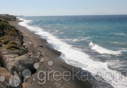
Location: North-east of the island
Description: This is one of the island’s most isolated beaches and one of its most quiet.
Nearest village: Finikia

Perivolos
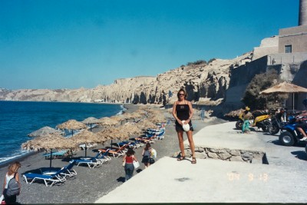
Location: East side of the island, couple of km from Perissa
Description: Perivolos is situated on the longest black beach of the island.
Nearest village: Perissa

MYKONOS :

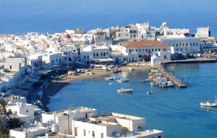

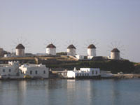

Break out the nightlife, include superb beaches, add thejet set, and you have Mykonos. This island is the Gateway to Delos: a small island, the supposed birthplace of Apollo and Artemis, which is filled with ruins to explore. Attractions: Petros the Pelican , Windmills, Little Venice, Paraportiani, Archaeological Museum, Aegean Maritime Museum, Folklore Museum, Folklore branch museums -.Lena.s House., Delos.
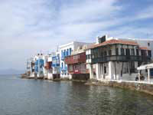
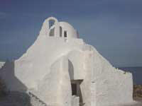
This is the Ibiza of Greece. A beautiful island in the Cyclades, which looks just like the postcards: white little houses with flowers and blue windows and doors, hand painted streets, windmills, pigeon keepers, chimneys, lots of little churches and wonderful restaurants and cafes.
What to See: The town Chora is a place you should really explore. Walk around, go to the windmills, feed the pelicans Petros ('Rock" and Irini ("Peace"), have a drink in the little harbour and visit the Parapotiani church. And of course, go shopping. There are also five museums: an archaeological, a folk museum, a maritime, a cultural and a private one with old rooms and furniture. Most of the museums of Mykonos are located at Enoplon Dynameon Street which is one of the busiest streets of Mykonos town during the summer. To reach this area is fairly straightforward, At the seafront, turn right by the ferry ticket office into Matogianni Street, walk the length of this street and turn right at the end - this is Enopolon Dynameon Street. Here you will find the Aegean Maritime Museum (opening hours 10.30-13.00 pm and 18.30-21.00 pm), next to it is the Folk Museum, the House of Lena, (open 18.30-21.00 pm). Another interesting building just before these 2 museums is the house where the Greek Numismatologist and Archaeologist, Giannis Svoronos, was born .
Further down just before the 3 wells are the churches of Saint George, that was built in the 15th century BC, and St Barbara and Saint Fanourios built in 1883.
Behind the primary school of Mykonos is the main square of Chora "Laka", a green oasis in the whitewashed Mykonos town with Eucalyptus and Palm trees and all kinds of shops and eateries around, here also you will find the post office. Walking up from there to the west you will reach the plateau where the famous windmills are located. These are one of the most popular landmarks of Mykonos. In olden times the people from all over the Cyclades would bring their wheat and barley to these mills to be made into flour.
Just beneath the windmills is the area of Alefkandra, or 'little Venice'. Its original name Alefkandra derives from its original use as a laundry and it was here that the women of Mykonos washed their clothes.
If you keep on walking through the winding small streets of Little Venice towards to the north, soon you will find the Paraportiani church another famous landmark of Mykonos.
The Paraportiani church in fact is 5 churches all built in a compact complex. It is one of the most photographed buildings of Mykonos and an amazing combination of white against the blue of the sky and the sea. Its structure over time has metamorphosised into an organic mass that resembles at one point a sparkling white iceberg stranded on the shore or at other points a huge cake dripping with icing sugar. From Paraportiani, the Kastro and the western part of the promenade are very close. In this area is the municipality building with its red clay roof. From this location the visitor can enjoy a panorama of the promenade of Mykonos. On the other side of the promenade at the taxi station in Manto square is the Statue of Manto Mavrogenous a Mykonian Heroic figure of the Greek War of Independence equivalent to Laskarina Bouboulina of Spetses island.
The little village Ano Mera is worth s visit: small, pretty and quiet. Visit the monastery and the little church museum from the 15th century.
There are daily excursion to Delos, a small island which used to be the holiest island in ancient Greece. Leto gave birth to Apollo and Artemis here, holding on to a palmtree. You can not spend the night on this island, but a daytrip is definitely a must: the island is cluttered with archaeological remains.
You can also go to another neighbouring island, Tinos, which is the holiest island of modern Greece. The church of the Virgin Mary is a goal for thousands of orthodox pilgrims every year. It is also a very beautiful place worth visiting.
What to Do There are lots of water sports offered, as well as diving, horse riding and swimming pools. There are also daily excursions to the beaches, as well as to Delos and Naxos. The best hours to enjoy Mykonos town is early in the morning when all the party crowds have been retreated in their hotels to gain powers for the next night. Strolling in the winding whitewashed streets of Mykonos in the morning is an unforgettable experience. Go for a coffee in the Little Venice and take photographs of the spotless white church of Paraportiani. As the noon approaching head for a swim at one of the numerous sandy beaches of Mykonos
Beaches The beaches are generally very busy. It is worth exploring the little bays on the south side. Platy Gialos and Elia are very popular beaches. Further from Platis Gialos are the famous nude beaches of Paraga, Paradise and Super Paradise, you can go there with boats that departing from Platys Gialos. Other beaches are in Agios Stefanos in the north, Kalafatis beach recommended for the lovers of wind surfing. Ornos beach, Agios Giannis, Agrari, all of those beaches and more that you can explore have made the island of Mykonos the most visited island of Greece.
Nightlife Most of the bars and clubs are in Mykonos Chora. They are quite stylish and the prices can sometimes be outrageous. There are also beach parties going on all through the summer so keep a lookout for advertising posters. For the Greek Music fans (Ellinadika) among the most popular is the Giuzel (former 9 Muses) at the east side of Akti Kambani, the Thalami next to the town hall and the Mykonos Bar. At the Three Wells you will find the famous Aegli one of the hot spots of Mykonos nightlife and on the other side of the road the Asteria and Coo bars. At The Caprice bar in Little Venice, from early afternoon, you can enjoy amazing sunset views. Nearby is located the famous Scandinavian bar . The well- known gay bar of Pierro's has been moved to the second floor in the square of Agia Kyriaki over the famous Manto bar, while Remezzo with its new name El Pecado Remezzo still has its top spot in Mykonos nightlife. The night party can go on until the morning and be continued in the famous beach bars of Mykonos like Cavo Paradiso and Tropicana in Paradise beach, Super Paradise bar, in Super Paradise beach, Sol Y Mar in Kalo livadi,and Elia bar in Elia beach.
Food There are both Greek and international restaurants and most of them are situated in Mykonos capital, Mykonos or Chora. The island's specialty is the Louza loukaniko - a special kind of sausage and Kopanisti a special kind of soft goat's cheese with lots of pepper. Actually any kind of eatery can be found in Mykonos, from souvlaki and Gyros to Italian pasta and pizza, crepes, fish taverns and haut cuisine restaurants . You will find many locals eating at the cafeterias and taverns along the promenade, particularly at Vasiliki's "Yalos" snack bar right oposite the fish market where you can enjoy Greek mezedes with ouzo, Calamari (squid) , fried fish and huge portions of local sausages at very reasonable prices.
Shopping Folklore shops are everywhere in Mykonos, and a great souvenir is a copy of ancient Cycladic art; little white figures in various positions (playing the flute, praying, thinking, families etc.) which are more than 6000 years old. The gold is also very good, and you can get clothes, ceramics, textiles and antiques if you are willing to pay the price. Many fashion shops are along Matogianni Street , including upmarket fashion and design names like Prince Oliver for clothing , costume jewellery like Folli Follie etc. Famous Greek jewellers can be found in Mykonos like Ilias Lalaounis jewellery opposite the Art Gallery of Giannis Galatis at Polykantrioti Street. If you are interested for something more local and traditional in Zouganeli Street you can buy local sweets and cakes made of almonds, the famous "Amygdalota", from Efthymiou sweet shop. Another unique shop of beauty products all made from Greek olive oil, The Olive Oil Shop, located also in the same street further towards to the town. Some of the local products of Mykonos like the cheese "kopanisti" you can find at the traditional grocers shop "Lykos" (the wolf) in Matogianni Street. In the Grill Tavern Spilia next to the primary school at Enoplon Dynameon Street you can buy local cheese and sausages from the tavern owner's production.
Getting Around There are good bus connections in Mykonos, as well as many car and bike rentals. It is not hard to get a taxi as well, and there are boat trips to many beaches. The night though is a bit tricky if you stay far from the centre of Mykonos town and you are looking for a taxi, you must be patient as the taxis are limited and the people coming out from the numerous clubs, bars and restaurants are too many. If you rent a car be aware that you can't drive it through the town and parking has become a problem especially in high season.
There are 3 parking spaces around Mykonos town. A good idea for a first visitor to the island is to get a taxi for a half or one hour drive around Mykonos in order to get to know the roads and the island as well. Some of the taxi drivers like Christos can be a good tour guide and get you through the most important areas and beaches of Mykonos plus telling you some really interesting facts about the island.
Staying in Mykonos: If you want to use Mykonos town as your base during your stay, which is quite a good reason as most things happen there, you can find accommodation within the town in numerous hotels, rooms and apartments. Zorzis hotel is located in one of the most central places in Mykonos town only a few dozen meters from the sea front, in a quiet small lane (Kalogera street) off of Matogianni street opposite the Alpha Bank. The hotel, with its elegant frontage, is small (10 rooms) and very comfortable and well furnished. With extremely reasonable prices. The friendly hotel owner and the staff will give you all information about Mykonos and ensure your stay is a pleasant one. More information at info@zorzishotel.com
Getting There Mykonos has its own airport. There are also good Ferry connections with the other Cycladic islands, as well as with Piraeus Athens and from Rafina. Super Fast Catamarans make the trip to Mykonos within a few hours. From the end of April there are connections with small boats to Paros and other islands of the Cyclades. From Mykonos you can visit Delos with daily boat trips, the first boat departs at 10 am and returns at 1.15 am. the ships depart from the west dock near the town hall.
RHODES:
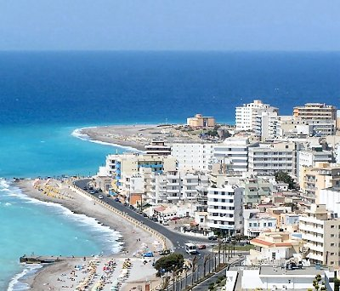
Rhodes was an important port through much of history. As you approach the island, you will be amazed by the medieval walled towncreated by the Knights of Saint John. The island offers great scenery, pleasant people, good shopping, and lots to do. Be sure to head to Lindos to see the ruins and the Temple of Athena. On the way up the hill to the temple, examine the fine linens that will be offered for sale on the trail up the cliff.
Introduction This is one of the best known Greek islands and holidaymakers have been coming here for many decades. It is a beautiful island, but the many years of tourism has definitely taken its toll. Everywhere in Lindos and Rhodes town you will see bars, discos, and restaurants with food from all over the world. On the one hand this might take away a bit of the "Greekness" of the island, but on the other hand you have everything you want here. Struggling to find somewhere to exchange money or trying to communicate through bodylanguage on a small island might be charming, but sometimes it is wonderful to have all the facilities, especially if you are travelling with children, or just want to have a fun holiday by the sea.
Many locals are involved with tourism in one way or the other, but there is also a lot of farmers on the island. They grow grapes and keep goats. Because it is a large island, many also have "ordinary" occupations: civil servants, shopowners, office clerks etc. There is also a large military base on the island.
Getting Around: The roads on Rhodes are quite good, so you can get around easily with a car or a bike. There is also a good local busnetwork, as well as many taxis. Several boats can take you on excursions to beaches

What to See in Rhodes:
The capital, Rodos, is in itself very beautiful. Just walk around in the Old Town and see where the streets take you. Mandraki is a nice area, and from the hill of Monte Smith you get a wonderful panorama view. It is in the harbour of Mandraki the two famous bronze deer stand where the colossus of Rhodes once was. The old part of the town is from the Middle Ages and you can visit the castle of the Grand Master as well as walk on the road of the Knights and visit the Castle of the Knights.
The white town Lindos is well worth visiting. The acropolis here was only surpassed by the acropolis of Athens, and you can still see its ruins.
The healing baths of Kallithea are on the Eastern side of the island.
On the West side of the island there are several picturesque villages. If you like ancient history the "Pompey of Greece", Kamiros, is definitely a place to go. The monastery of Filerimos is also a place worth a visit.
Sianna is often considered the most picturesque village.
The Valley of Butterflies (Petaludes) is full of butterflies and is very pretty.
What to Do: Rhodes has many options for grown ups as well as children. There are lots of watersports, as well as tenniscourts, golf and horseriding. In Afandou there is a Casino which is Greece's third in size. You can also dive in Kallithea. The island is also great for exploring on your own.
Rhodes Beaches: The best beaches are situated on the east coast. It is not too windy there and most beaches there are suitable for families with children. Surfers prefer Prasonisi in the South. At Cape Ladiko there is a small bay with the incredible name Anthony Quinn which is very nice. This is where The Guns of Navarone was filmed. There are also many, many more beaches.
Rhodes Nightlife: You'll find loads of bars, pubs, discos and clubs here on Rhodes. There is something for every taste, both foreign and Greek. The wildest partying goes on in Rhodes town mainly at the new town and Lindos, but there are also many nice places in the quieter parts.
Food: The local wine and sparkling wine worth a try. The Greeks call the latter champagne, but it is much cheaper than the real thing.. There is also a local drink called Soima made of grapes, as well as a special kind of honey. There are taverns all over the island. The real traditional Greek taverns are in the smaller villages, and in Rhodes town and Lindos there is a wide range of international as well as Greek restaurants.
Shopping in Rhodes: You can get all kinds of things here. There are ordinary shops where you can buy clothes, shoes, books, things for the beach, glasses and so on. Then, there are the souvenir shops where everything Greek can be bought: leather belts, gloves, bags, icons, embroideries, copies of ancient art etc.
Getting There: There is an airport on the island of Rhodes where almost all charter flights land. The airport also has flights within Greece to both islands with airports as well as with Athens Greece and Thessaloniki. The island is also connected with the rest of the Dodecannese, as well as Crete, the Cyclades, Pireus and Alexandroupolis. There are also ferry connections with Cyprus and Israel

KERKYRA (CORFU):
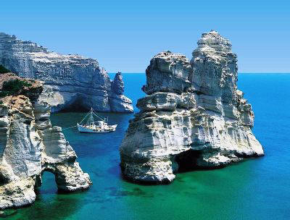

Corfu is one of the most popular islands and attracts every year thousands of visitors. It is the northerly island of the Ionian Group of Greece and lies at the entrance of the Adriatic Sea. It is the second largest island of the Ionians. It is a mountainous island with impressive landscapes, dense vegetation due to many rainfalls in winter, long golden sandy beaches, one of Greece’s most beautiful towns, many traditional villages, Byzantine churches, several museums, impressive Venetian fortresses and lively resorts all around
the island. The island of Corfu was one of the first islands in Greece to open itself to tourism and has everything to offer to the visitor.

What to See: The citadel in the harbour was made by the Venetians. The Regency palace in the town was built by the British, and the French made a copy of Paris's Rue de Rivoli. This gives the island its typical European style.
To really see the beauty of the island you should rent a car and go to some of the pretty villages and deserted beaches. For example, you should visit Sidari, Aharavi, Dasia, Ypsos, the channel of love, the fishing villages Benitses, Moraitika etc. From Kassiopi you can see Albania if the weather is clear enough.
If you want a taste of the cosmopolitan side of Corfu, you can visit the most popular square Spianada in the town for a coffee or a drink. The palace Achilleon where the empress Sissy lived is quite splendid.
The old and new Castro are worth visiting, as well as St. Spyridon, with the tallest bell tower of the island. The palace of Ag Michael and Georgiou and the church of Vlahernas are other places of interest.
There is an archaeological museum you definitely should go to if you are interested in ancient history.
Just outside town is an area called Pontikonisi, which not only is beautiful, but also has a church dedicated to the Virgin Mary from the 13th century. This is probably the most photographed spot in Corfu.
On a cliff just by the most popular beach, Paleocastritsa, there is a 13th century monastery, which holds the huge bones of a whale. At Kalami you can see the house of Lawrence Durell.
What to Do: Watersports are available at many beaches, as well as diving and biking. You can also go horse riding in Ermone and Sidari. In Sidari there are also some really nice tracks for walking.There is an 18 hole golf course. Watch cricket matches in Corfus capital or go to the casino. Around the island, especially by the bigger hotels there are tennis courts. A must for the young is the Waterland in Gouvia.
Corfu Beaches: There are many beaches on the island, but they are all situated outside the town. The most famous one was the one Odysseus was allegedly washed ashore on, Paleocastritsa, but there are many more choices: Sidari, Ermones and Kavos are only a few of the nice beaches. Agios Georgios is very long (3km) and great for watersports and families with children.
Corfu Nightlife: The busiest areas are Mandouki (also called the Disco Strip) and the capital Kerkyra. The Bond film 'For your eyes only' was shot here.
Food in Corfu: The local pie is worth a try, as well as and Sofrito which is cooked meat with carrots, garlic and onion. Kumquat is a special liqueur made from Japanese oranges grown on the island.
Corfu Shopping: The most typical local product is the ceramics. There are a lot of wooden things to buy - jewellery, toys, houseware etc. You can get a bottle of local wine, or why not a bottle of Kumquat. Leatherware, clothes, rugs, icons and embroidery are other nice souvenirs.
Getting Around in Corfu: There are many good roads on Corfu as well as a local bus service It is also easy to rent cars and bikes. We have a nice map of Corfu to help you getting around the island of Corfu.
Corfu Getting There: Corfu has its own airport which is also connected to Athens. Ferryboats and hydrofoils go between Corfu and Igoumenitsa daily, and the trip with the ferry takes about 1 ½ hours. You can also get here by boat from Patra. Several times a day there are also ferries to Italy.
ARTS AND CULTURE
Greece is full of archaeological sites and monuments of distinctive prestige and charm, on which all known periods of its longstanding history have left their mark. Visitors have the opportunity to make a unique journey through the rare mosaic of historic and cultural memory, which has left an indelible mark on every region of the country and effortlessly highlights the manifold manifestations of Greek culture to date. According to the UNESCO catalogue, the following archaeological sites and cultural areas in Greece have been characterised as Monuments of Cultural Heritage:

OLYMPIA
One of the most important sanctuaries of antiquity, dedicated to the father of the gods Olympian Zeus. Olympia is the birthplace of the Olympic games, which were first held here in 776 BC to honor Zeus. The Olympic games where ceased in 393 AD after an edict issued by Theodosius the Great and were revived for the first time, after fifteen centuries in 1896 in the all-marble Stadium of Athens. According to Greek mythology, Apollo was born on this tiny island in the Cyclades archipelago. Apollos sanctuary attracted pilgrims from allover Greece and Delos was a prosperous trading port. The island bears traces of the succeeding civilizations in the Aegean world, from the 3rd millennium B.C. to the palaeochristian era. The archaeological site is exceptionally extensive and rich and conveys the image of a great cosmopolitan Mediterranean port.

DELOS
According to Greek mythology, Apollo was born on this tiny island in the Cyclades archipelago. Apollo.s sanctuary attracted pilgrims from allover Greece and Delos was a prosperous trading port. The island bears traces of the succeeding civilizations in the Aegean world, from the 3rd millennium B.C. to the palaeochristian era. The archaeological site is exceptionally extensive and rich and conveys the image of a great cosmopolitan Mediterranean port.

DELPHI
One of the most famous archaeological sites in Greece, Delphi offers interesting excavations of the Oracle.s world. The Delphi Museum includes the Charioteer and other important statues. Attractions: The Angelos and Eva Sikelianos Museum, The Delphi Museum, The Sanctuary of Apollo

VERGINA
The city of Aigai, the ancient first capital of the Kingdom of Macedonia, was discovered in the 19th century near Vergina, in northern Greece. The most important remains are the monumental palace, lavishly decorated with mosaics and painted stuccoes, and the burial ground with more than 300 tumuli, some of which date from the 11th century B.C. One of the royal tombs in the Great Tumulus is identified as that of Philip II, who conquered all the Greek cities, paving the way for his son Alexander and the expansion of the Hellenistic world.

MYCENAE AND TIRYNS
The archaeological sites of Mycenae and Tiryns are the imposing ruins of the two greatest cities of the Mycenaean civilization, which dominated the eastern Mediterranean world from the 15th to the 12th century B.C. and played a vital role in the development of classical Greek culture. These two cities are indissolubly linked to the Homeric epics, the Iliad and the Odyssey, which have influenced European art and literature for more than three millennia.

Historic centre (Chora) and the cave of the apocalypse on the island of Patmos
The small island of Patmos in the Dodecanese is reputed to be where St John the Theologian wrote both his Gospel and the Apocalypse. A monastery dedicated to the beloved disciple was founded there in the late 10th century and it has been a place of pilgrimage and Greek Orthodox learning ever since. The fine monastic complex dominates the island. The old settlement of Chorá, associated with it, contains many religious and secular buildings.

NIGHT LIFE
When you are in Athens you will probably get the impression the city never sleeps, for when sunset gives way to evening you will soon discover that Athens begins to live by night! To a great extent this is true, as no other city in the world offers so many alternatives. Early in the evening, you may want to check out an ancient Greek drama being presented at the play was written! Or maybe even see a world famous orchestra playing Mozart at the Meragon one of the finest modern concert halls in Europe, one of the finest modern nightclub circuit and ethnic music scenes here quite unique from anywhere else you will find in the world like, you can check out the indicative ready-made packages that follows. Feel free to choose one of them, but keep in mind that we prefer to design a tailor-made.

SPA
Apart from the rare landscapes and special natural beauties, nature also endowed Greece with springs with important therapeutic properties. Spas are part of the country’s national wealth, while their therapeutic properties were already known in ancient times. Natural mineral resources are scattered all over the country; while the water of these springs differs from common water, either due to the high temperature or to the presence of rare drastic components. The water of these springs is marked as mineral water, because of the temperature the general chemical composition. Apart from cold mineral springs, there are also hot springs and these are the ones used in therapeutic treatment: spa hydrotherapy (thermalism). The geographic allocation of the springs is not accidental as it is connected either with tectonic events, as is the case for example for the springs of Kaifa, Kyllini and Langada, or with volcanic activities, as in the case of the springs of Methana, Milos, Lesbos, Samothrace, and Limnos. Hydrotherapy is particularly important for the treatment of multiple affections such as arthritis and rheumatic diseases, and falls into two categories:-internal therapy, which includes drinking therapy (drinking of natural mineral waters), inhalation therapy (inhalation of fumes or droplets of mineral water) and lavages (oral, nasal, gynaecological)- external therapy, which includes baths, jet showers (the body is hit by thermal mineral water under high or low pressure for a specific period of time), hydromassaging (the pressure of the water massages the body), hydrokinesotherapy (combination of balneotherapy and kinesotherapy for the period of time the body is inside the water) and fangotherapy (application of mud, which has .ripened., on those parts of the body that suffer from various disorders).

INDIAN RESTAURANTS IN ATHENS
Gurou 17, Poseidonos Vouliagmen
Tel: 8964437 Opening Hours: 19:00 - 03:00

Jaipur Palace
Ag Konstantinou & Themidos 73 Marousi Greece Zip Code: 15124 Tel: 210 8052762

Altamira Kolonaki 36a Tsakalof St, Kolonaki Greece
Tel: 210 361 4695

Viceroy Ipsos 49083 Corfu Greece Opening Hours: March till May Fridays & Saturdays 7.00 - 11.00 From May every day except Monday 7.00 - 11.00

Red Indian
Epikourou 25, Psiri.
Open every day except Monday. 8:00 pm-2:00 am winter. 9:00 pm - 2:00 am summer.
Owner's name: Asgar Aslan
Special Dishes: Chicken Tadoori and Curry Lamb with plain naan (Indian bread)
Chef's favorite: Jalfrez chicken and beef with fried rice and peas. Very spicy
Seating capacity: 120
Approx Cost: Euro 30 per person Dress code: Formal

Pak Indian
Menandrou 13 Psiri
Open: 8:00 PM.-3:00 AM. Closed Mondays.
Owners Name: The same as the RED INDIAN. This is Mr. Aslan's new restaurant.
Special Dishes: Tandori Chicken. This is baked in a clay bowl in a real Indian oven.
Chef's favorite: All curry dishes.
Seating capacity: 120
Approx Cost: Euro 25 per person Dress code: Casual

